MBEYA UNIVERSITY OF SCIENCE AND TECHNOLOGY
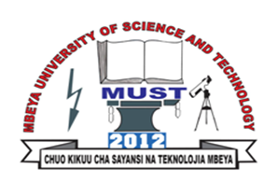
College of Humanities and Business Management
Department of Business Management
INDIVIDUAL ASSIGNMENT – 10 Marks.
Instructions
- Read about the following development theories (Choose any two among the theories and summarize key points for presentation- Maximum 1 page)
- Modernisation theories (1950’s, early 1960's)
- Dependency theories (late 1960's, early 1970's).
- World economy view (late 1970’s, early 1980's)
- Basic needs approaches (late 1970's)
- Alternative modes of production perspective (1980’s)
- Sustainable livelihood approach.
- Answer only One question among the following;
- Discuss the various measures of human development and the problems relating to its measures.
- Critically discuss Malthusian theory of development.
- Explain, according to Marx how capitalism leads to the emergence of socialism.
- Is the Marxist theory of social development still valid in the 21st century? If so, indicate why?

